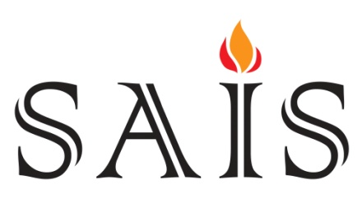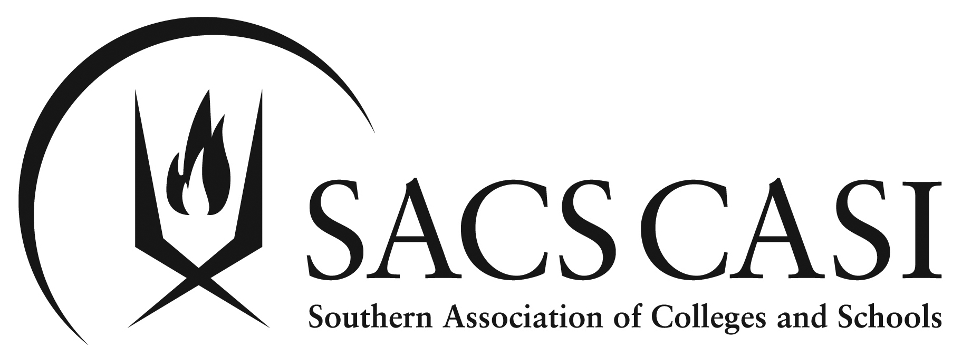

Southern Association of Independent Schools
Southern Association of Colleges and Schools

SAIS-SACS Accreditation

VISIT REPORT

for

School Name

Mailing Address

Head of School Name
E-mail
Phone

Board Chair Name
E-mail
Phone

Date of Visit

Name of Visiting Team Chair
Title / School of Visiting Team Chair

Southern Association of Independent Schools
and
Southern Association of Colleges and Schools:
A History of SAIS-SACS Accreditation

SAIS and SACS member schools are part of a remarkable history of quality assurance in education.

SAIS began its organizational life in 1903 as the “Mid-South Association of Independent Schools,” providing training for teachers in private schools and some early public schools in the southeastern states. In 1953, another organization began as the Southern Association of Independent Schools, providing a forum for independent school administrators to work with public schools through SACS and to contribute to the larger interest in accreditation in the southeast. MAIS and SAIS merged in 1986 to form the present SAIS, with an emphasis on accreditation through SACS for independent schools and professional development for administrators, trustees, and teachers. Today, SAIS works to help both established and emerging schools approach these issues with creativity and innovation. Working at the state, regional, and national levels, SAIS serves and strengthens member schools through the promotion of the highest quality educational standards and ethical conduct.

Established in 1895, the Southern Association of Colleges and Schools (commonly referred to as SACS) is a non-governmental, voluntary organization that accredits more than 13,000 public and non-public institutions from early childhood through university. Since its inception, SACS has served the educational community by dedicating its mission to helping schools improve student learning. Today, SACS is the largest accrediting agency in the world and is one of only six agencies that accredit both public and nonpublic educational institutions.

The current partnership offers schools a process for achieving SAIS-SACS accreditation. In today’s world of accountability in schooling, accreditation serves as a critical component of a school’s demonstrated effectiveness and ability to provide successful schooling for children. A school that is able to achieve accreditation demonstrates a commitment to a process that requires the school to meet a set of rigorous, research-based standards; to engage in a program of continuous school improvement; and to demonstrate quality assurance to its stakeholders through self-evaluation and peer review. SAIS-SACS accreditation provides schools access to an integrated network of services and technical assistance that supports every school’s ability to identify and meet its goals for improving student performance and the teaching and learning process.

A SAIS-SACS accredited school is part of an international network of accredited schools which have demonstrated success in educating children. As such, SAIS-SACS accreditation is recognized throughout the world as a symbol of quality in education for students and teachers.

To earn accreditation, schools must meet quality standards, be evaluated by an outside group of peer professionals, and implement a school plan focused on strategic improvement and student performance. Accreditation is voluntary and must be renewed each year.
Roster of Team Members

Chair

Name
Title
School
Address
Phone
E-mail

Team Members

Name
Title
School
Address
Phone
E-mail

Name
Title
School
Address
Phone
E-mail

Name
Title
School
Address
Phone
E-mail

Name
Title
School
Address
Phone
E-mail

The Review

A team representing SAIS and SACS conducted an on-site visit to review this school’s self-study and standards compliance. The team was comprised of team members whose diverse independent school backgrounds provided an array of expertise. The visiting team sought the answers to these four critical questions within the framework of the school’s self-study. The following pages contain the findings.

In conducting the on-site reviews, the visiting team was responsible for:
- Assessing the adequacy of the self-study process;
- Identifying strengths of the school deserving commendation;
- Developing recommendations that may help to strengthen the programs of the school;
- Assessing compliance with the standards of SAIS-SACS;
- Developing a written report of the findings.

To fulfill the team’s responsibilities, team members:
- Reviewed documentation provided by the school;
- Conducted interviews with board members, parents, school personnel, students, and
community members;
- Applied the standards for accreditation;
- Developed a draft of commendations and recommendations;
- Contributed to the content and focus of the written report;
- Provided input as to the determination of accreditation.

The primary focus of the self-study process is to demonstrate the capacity of a school to meet the requirements for accreditation. A typical self-study consists of:
- Analysis and response to accreditation standards;
- Identification and demonstration of a continuous process of improvement;
- Implementation of methods that provide for quality assurance.

The study addresses four critical questions:
- PROFILE: Where is the school today? The PROFILE should include clear, comprehensive information reflecting current student performance data, stakeholder perspectives, community characteristics, and analysis of strengths and limitations in the areas of student learning and school performance.
- VISION: Where does the school want to go? The VISION is a clear, compelling purpose communicated through the school’s vision and mission statements, beliefs, and core values.
- PLAN: What is the plan to get there? The PLAN should be based on an analysis of pertinent data, research of best practices, and alignment with generally-accepted expectations for student learning at schools with similar missions.
- RESULTS: How will the school know when it has accomplished its plan? The RESULTS are documented evidence demonstrating successful implementation if strategies that resulted in accomplishment of the school’s mission and student achievement gains related to the school’s mission.

The Self-Study

What to include in this section:

- Windsor Academy was established as a private, non-profit, 4K-12, school in 1979. Twenty acres of land were purchased and groundbreaking ceremonies took place on April 30, 1970. The original founders chose the name, Windsor, meaning “importance , grandeur, or the very best” and assumed as their pledge: “Gain not loss; Good not evil, Success not failure.” The school opened its doors on August 31, 1970 with twelve classrooms and 215 students. The first graduation with four students was held on June 4, 1971. A gymnasium complex was added in 1973 and an annex to the lunchroom and four additional classrooms were added in 1976. By 1981, enrollment reached 500. An electrical fire in 1985 caused severe structural and smoke damage to the gymnasium, lunchroom, and classrooms. Classes were held at various churches and the community center until the building was restored. A second gymnasium with classrooms and a science lab were dedicated in 1993.

- Currently, the school has a population of 231 students in Grades 4K – 12. For the past three years, the school has experienced a decline in student enrollment. Windsor Academy is governed by a Board of Trustees .

The school’s staff reports directly to the headmaster including 2 administrators, an administrative assistant, a bookkeeper, a counselor, 2 custodians, and 20 teachers. Windsor Academy is a member of the Georgia Independent School Association (GISA).

- Current school statistics and leadership structure
- How the school selected and approached the self-study

PROFILE

PROFILE: Where is the school today?

(Insert your commentary on school profile)

Commendations:
The visiting team commends the school for:

- Abc
- Xyz
- 123

Recommendations:
The visiting team recommends that the school consider:

- Abc
- Xyz
- 123

VISION

VISION: Where does the school want to go?

(Insert your commentary on school vision)

Commendations:
The visiting team commends the school for:

- Abc
- Xyz
- 123

Recommendations:
The visiting team recommends that the school consider:

- Abc
- Xyz
- 123

PLAN

PLAN: What is the plan to get there?

(Insert your commentary and brief description of school plan)

Commendations:
The visiting team commends the school for:

- Abc
- Xyz
- 123

Recommendations:
The visiting team recommends that the school consider:

- Abc
- Xyz
- 123

RESULTS

RESULTS: How will the school know when it has accomplished its plan?

(Insert your commentary on school’s results. Do you think the school’s plans to evaluate their results are sufficient?)

Additional Commendations and Recommendations

Note to chair and team: We anticipate that the commendations and recommendations you listed under the four areas will NOT be repeated in this category. This last general category can be left blank. But just in case you and the visiting team cannot reasonably relate one of your commendations or recommendations to one of the other areas, this is the opportunity to write something of use to the school in a general area. If you do make any commendations or recommendations in this category, we will treat them with the same weight.

Commendations:
The visiting team commends the school for:

- Abc
- Xyz
- 123

Recommendations:
The visiting team recommends that the school consider:

- Abc
- Xyz
- 123

SUMMARY

A few ideas for what to include in this section – you are by no means limited to these things:
- What type of community did you find at the school?
- Describe the collaboration between stakeholders
- Were expectations set and on target?

CONCLUSION

(Insert comments and recognition if appropriate.)

The visiting team finds:
- That the school is in compliance with all standards of the SAIS-SACS accreditation process.
- That the self-study conducted by the school meets the standard of quality and thoroughness required by the SAIS-SACS accreditation process and answers the four critical questions as outlined in the Guidebook.
- That the school is unanimously recommended for SAIS-SACS accreditation.

